- Circles –chords and tangents
1. In the figure below not drawn to scale. DC is a tangent to the circle. DC = 6cm, AB = 5cm. calculate BC. (3mks)
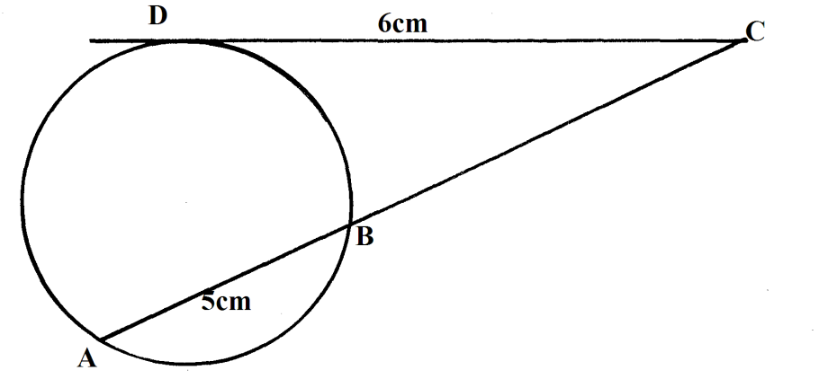
2.
A
B
K
D
C
G
3x⁰

The figure above shows a circle in which chords AD and BC intersect at G. chords AB and CD produced meet at K.
(a) If 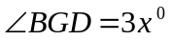 and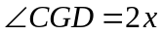, determine the size of 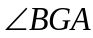 (2 mks)
(b) Given that KB = 5 cm, KC = 15 cm and KD = 7 cm, determine the length of KA (3 mks)
(c) Giving reasons for your answer, show that triangle KDA and KBC are similar (5 mks)
3. The figure below shows a circle with secants ABE and CDE, If AB = 4cm and BE = 6 cm and DE = 4 cm. Find the length of CD. (2mks)
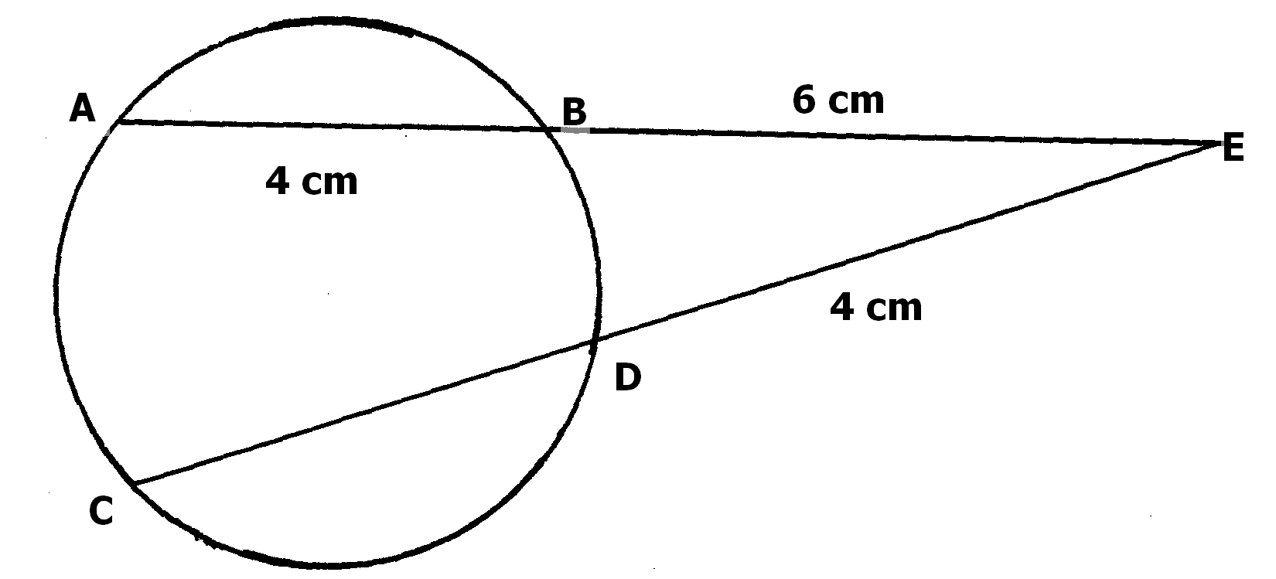
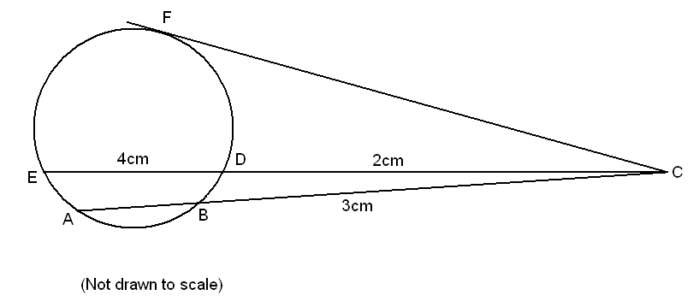
4. In the figure below, CF is a tangent to the circle. BC = 3cm, ED = 4cm and DC = 2cm.

Find:-
- AB (2 mks)
- FC (2 mks)
5. In the figure below angle BAC =52º, angle ACB = 40º and AD = DC. The radius of
the circle is 7cm. EF is a tangent to the circle
A
F
C
E
B
O
D
40º
G
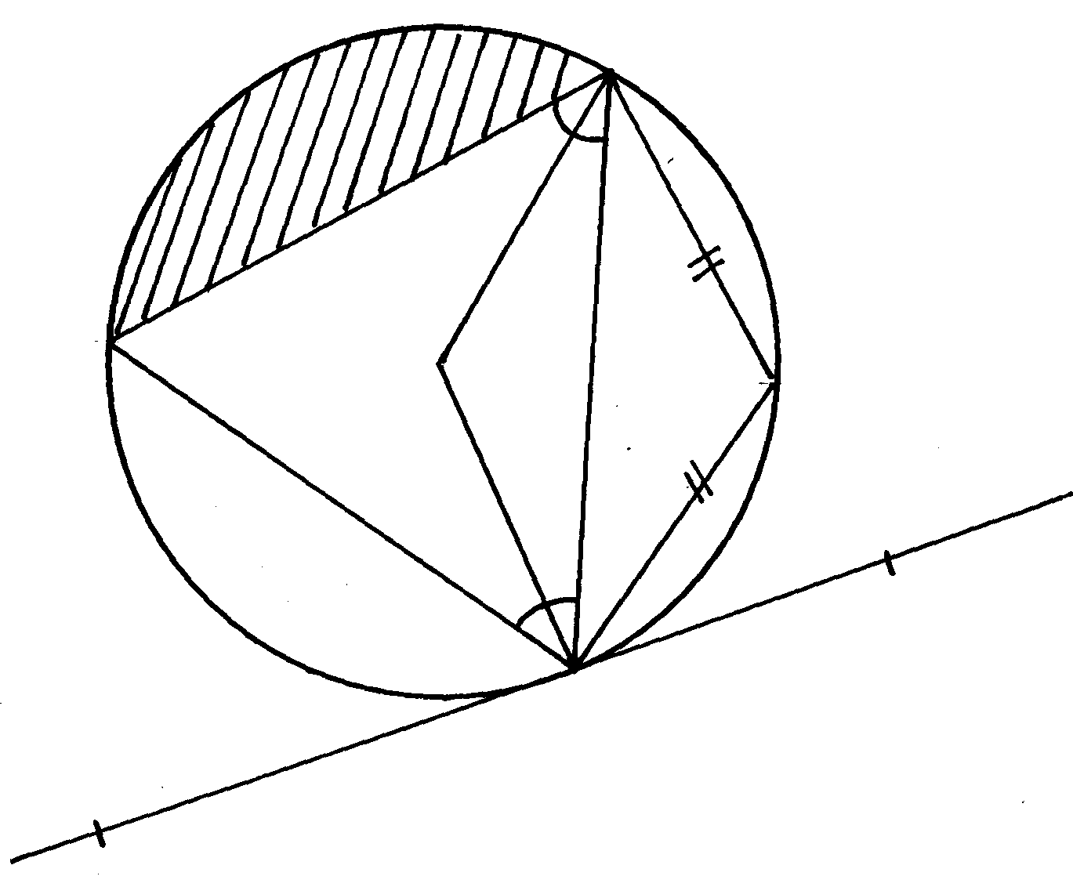

52º

(a) Find; giving reasons
(i) angle DCF
(ii) angle AOB (obtuse)
(b) Calculate the area of the shaded segment AGB

6. In the figure below, O is the centre of the circle. Angle CBA = 50º and angle BCO = 30º.
Find the size of the angle BAC
B
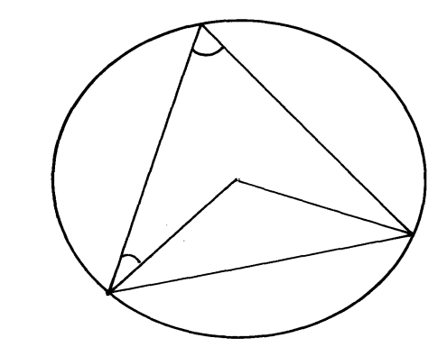
50º

O

A
30º

C

7. In the given figure, O is the centre of the circle and AOBP is a straight line. PT is a
tangent to the circle. If PT = 12cm and BP = 4cm. find the radius of the circle
O
A
P
T
4cm
12cm
B

8. In the figure below AOD is a diameter of the circle cetre O. BC is a chord parallel to AD. FE is a
tangent to the circle. OF bisects angle COD. Angle BCE = angle COE = 20º BC cuts OE at X
•
A
O
D
F
E
C
B
20º
20º
X

Calculate;
(a) angle BOE
(b) angle BEC
(c) angle CEF
(d) angle OXC
(e) angle OFE
9. The figure below shows two pulleys of radii 6cm and 4cm with centres A and B respectively.
AB = 8cm. The pulleys are connected by a string PQXRSY
P
Q
Y
X
A
B

8cm
R
Calculate:
S
(a) Length PQ
(b) ∠PAS reflex
(c) Length of arc PYS and QXR
(d) The total length of the string PQXRSY
10. a) Two pipes A and B can fill a tank in 3hrs and 4 hrs respectively. Pipe C can empty the full tank
in 6 hrs.
i) How long would it take pipes A and B to fill the tank if pipe C is closed?
ii) Starting with an empty tank, how long would it take to fill the tank with all pipes running?
b) The high quality Kencoffee is a mixture of pure Arabica coffee and pure Robusta coffee in
the ratio 1 : 3 by mass. Pure Arabica coffee costs shs. 180 per kg and pure Robusta coffee costs
sh 120 per kg. Calculate the percentage profit when the coffee is sold at sh 162 per kg.
11. In the figure below, ABCD is a cyclic quadrilateral and BD is a diagonal. EADF is a straight line,
∠CDF = 68º, ∠ BDC = 45º and ∠ BAE = 98º.
E
A
D
F
B
C
98º
45º
68º

Calculate the size of:
a) ∠ ABD.
b) ∠ CBD

12. The figure below shows a circle centre O. AB and PQ are chords intersecting externally
at a point C. AB = 9cm, PQ = 5cm and QC = 4cm. Find the value of x
C
P
B
x
4cm
A
5cm
9cm

13. The chords AB and PQ intersects internally at O. Given that the length of OP=8cm,
OA= 4.5cm and OQ=6cm. Calculate the length of OB
P
B
Q
A
O
4.5cm
8cm
6cm

14. In the figure below ABC is a tangent to the circle at B. given that <ABG=40º,
<BGD=45º, and <DBE=25º as shown below.
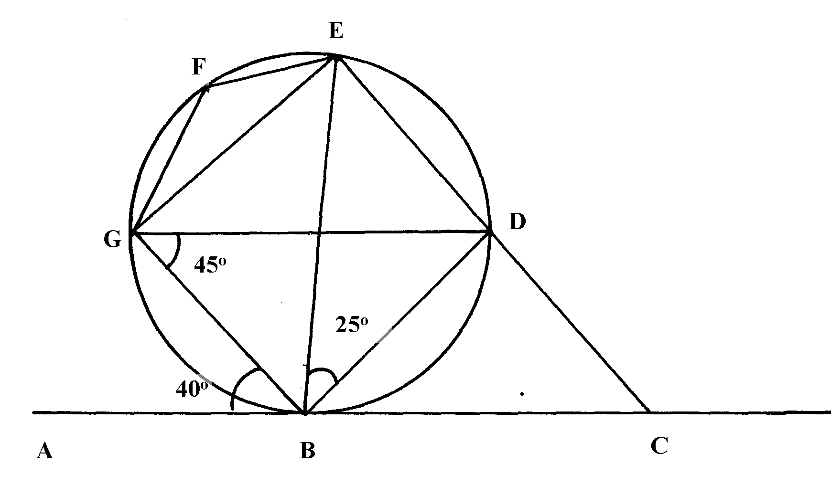

Find the sizes of the following angles giving reasons in each case:
a) ∠BDG
b)∠DGE
c)∠EFG
d)∠CBD
e)∠BCD
15. The figure below shows two intersecting circles radii 8 cm and 6 cm respectively.
The common chord AB = 9cm ad P and Q are the centres as shown:
A
B
Q
P
8cm
6cm

(a) Calculate the size of angles:-
(i) ∠APB
(ii) ∠AQB
(b) Calculate the area of the shaded region

16. The figure O and P are centres of two intersecting circles. ABE is tangent to circle BCD
•
•
O
C
42º
A
D
E
B
P
at B angle BCD is 42º

- Giving reasons for your answer, find:-
(i) CBD
(ii) DOB
(iii) DAB
(iv) CDA
b) Show that ΔADB is isosceles

17.
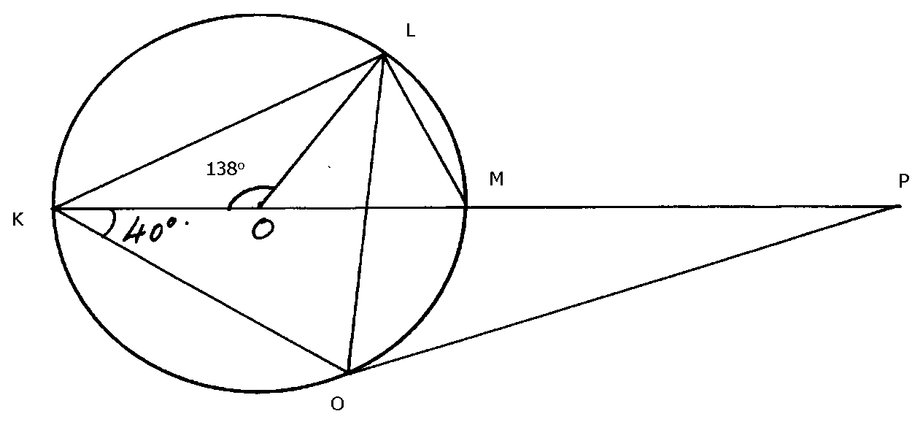

N

In the figure above K, M & P are points on a straight line. PN is a tangent of the circle centre O.
Angle KOL = 130º and angle MKN = 40º. Find, giving reasons, the values of angles.
- ∠MLN
- ∠OLN
- ∠LNP
- ∠MPN
- ∠LMO
18. In the diagram below, O is the centre of the circle of radius 8cm. BA and BC are tangents
to the circle at A and C respectively. PD is the diameter and AC is a chord of length 8cm.
Angle ADC = 120º. ARC is an arc of the circle, Centre B and radius 4.6cm
Calculate correct to 2 decimal places
A
C
• O
B
P
R
D
(a) Angle ABR
(b) Area of sectors ABCR and OAPC
(c) Area of the shaded part

19. In the figure below, ATX is a tangent to the circle at point T, ABC is a straight line, angle
ABT = 100º, angle XTD = 58º and line AB = line BT. C and D lie on the circle
C
B
A
D
100º
T
X
58º

Find by giving reasons, the value of angle:
- TDC
- TCB
- TCD
- BTC
- DTC
20. In the figure below, B, D, E, F and G are on the circumference of the circle centre O. A, B
and C form a tangent to the circle at point B. GD is the diameter of the circle. Given that
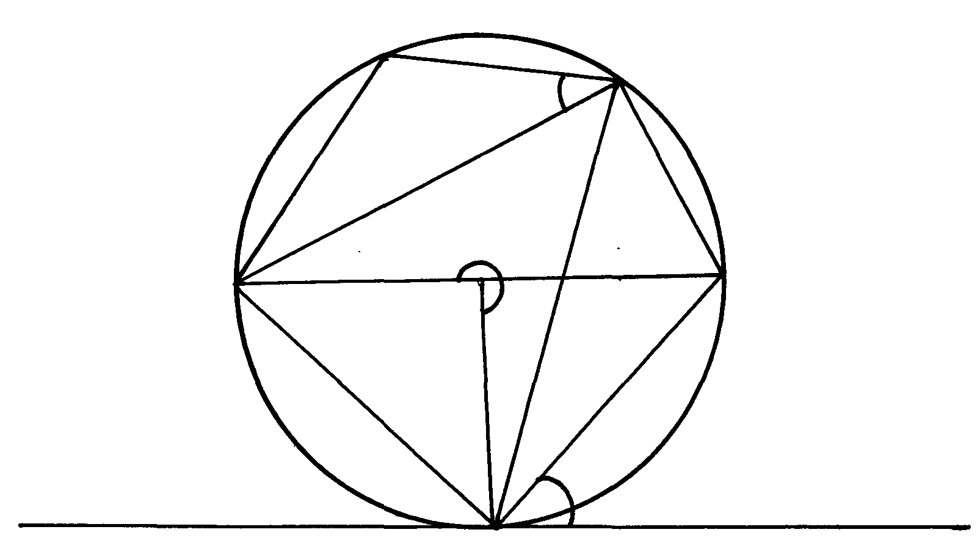
FG = DE, reflex angle GOB = 252°, angles DBC = 36° and FEG = 20°
D
36º
252º
20º
C
B
A
G
F
E
O

Giving reasons in each case find the angles:
a) GEB
b) BED
c) OBE
d) BGE
e) GFE
21. XYZ is a triangle in which x = 13.4cm, Z= 5cm and ∠XYZ =57.7º . Find:
(i) Length of XZ
(ii) The circum radius of the triangle
22. In the figure shown below, the centers of the two circles are A and B. PQ is a
common chord to the two circles. AP = 6cm, BP=4cm and PQ =5cm
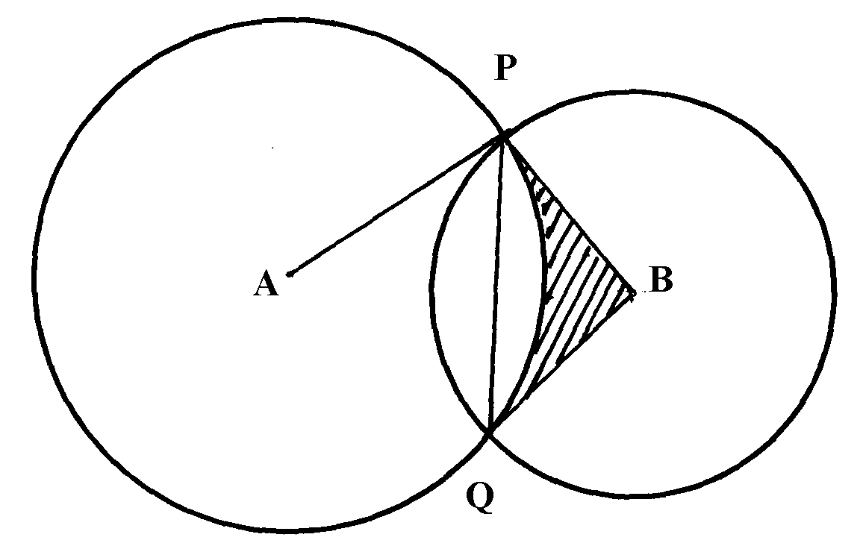

Calculate the area of the shaded region (take π as 3.142)
23. In the figure below NR is a diameter of the circle centre O. Angle PNR = 750⁰ ∠ NRM = 50⁰
and ∠RPQ = 35⁰. MRS and PQS are straight lines.
N
M
R
50º
O
P
75º
35º
S

Giving reasons for every statement you write, find the following angles
(a) ∠ PQR *
(b) ∠QSR
(c) Reflex ∠POR
(d) ∠ MQR
(e) ∠ PON

24. In the diagram below, ATX is a tangent to the circle at point T, ABC is a straight line,
∠ABT= 100º , ∠XTD = 58º and the line AB = BT
100º
58º
A
B
T
X
D
C

Find giving reasons the value of :
(a) ∠TDC
(b) ∠TCB
(c) ∠TCD
(d) ∠BTC
(e) ∠DTC

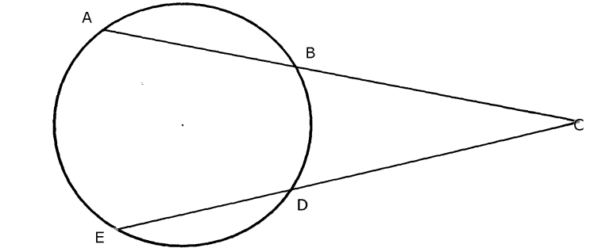

25.

In the figure above AB = 6 cm, BC = 4 cm DC = 5 cm. Find the length DE.

26. The eleventh term of an AP is four times the second term. If the sum of the first seven terms
of the AP is 175, find the first term and the common difference
27. In the diagram below ABE is a tangent to a circle at B and DCE is a straight line.

If ABD = 60º, BOC = 80º and O is the centre of the circle, find with reasons ∠BEC
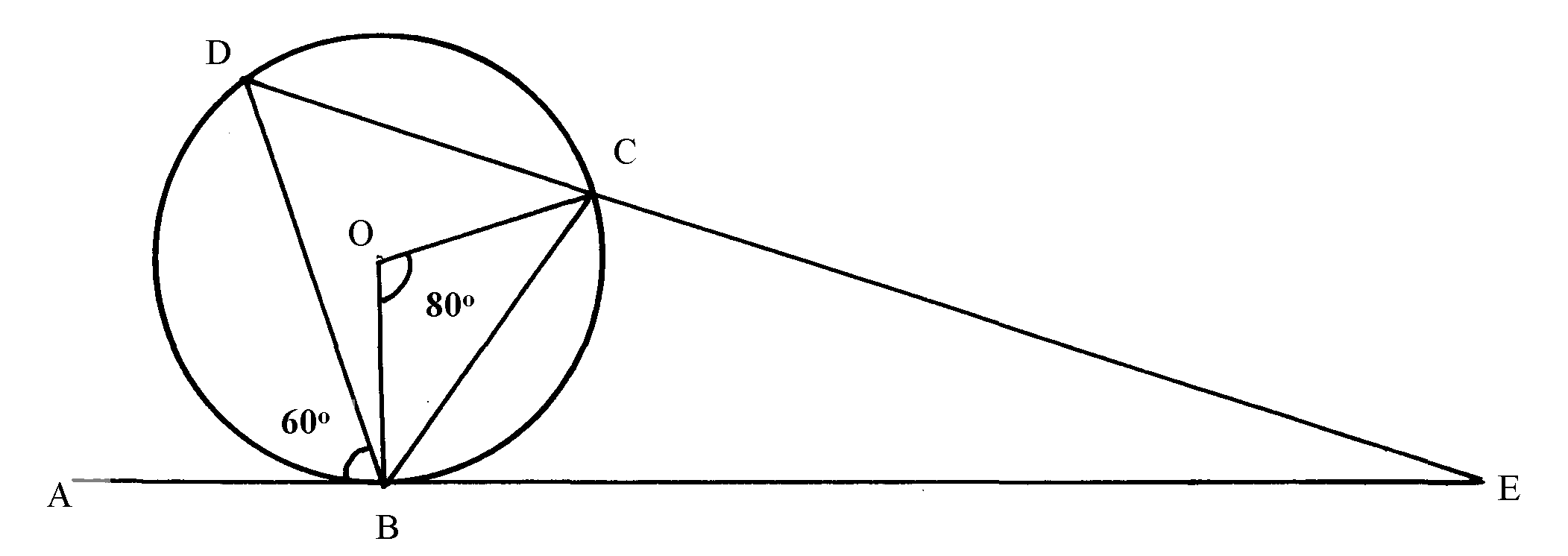

28. The circle below circumscribes a triangle ABC where AB = 6.3cm, BC = 5.7cm and
AC = 4.8cm. Find the area of the shaded part (use π = 3.142)
4.8cm
5.7cm
6.3cm
B
C
A

Q
R
S
P
56º
T
O
38º

29.

(a) O is the centre of the circle and QOTS is a diameter. P, Q, R and S are points on the
circumference of the circle. Angle PQS = 38º and angle QTR = 56º.
Calculate the size of ;
(i) ∠PRQ
(ii) ∠RSQ
(b) Given that A varies directly as B and inversely as the cube of C and that;
A = 12 when B = 3 and C = 2. Find B when A = 10 and C = 1.5
(c) A quantity y is partly constant and partly varies inversely as the square of x.
The quantity y=7 when x=10 and y=5½ when x=20. Find the value of y when x=18
30. The figure below shows two intersecting circles with centres P and Q and radius 5cm
and 6cm respectively. AB is a common chord of length 8cm. Calculate;
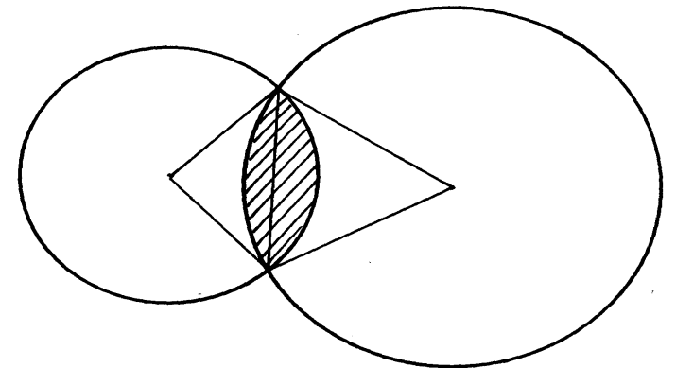
A
6cm
5cm

P
Q

:
B

(a) the length of PQ
(b) the size of;
(i) angle APB
(ii) angle AQB
(c) the area of the shaded region

31. Triangle ABC is inscribed in the circle. AB= 7.8cm, AC 6.6cm and BC= 5.9cm. Find:

(a) The radius of the circle correct to one decimal place
(b) The area of the shaded region
32. The figure below shows two circles centres A and B and radii 6 cm and 8 cm respectively. The
circles intersect at P and Q. Angle PAB = 42⁰ and angle ABQ = 30⁰.

42º
30º
B
8cm
6cm
q
Q
A
P

(a) Find the size of ∠PAQ and PBQ.
(b) Calculate, to one decimal place the area of:
(i) Sector APQ and PBQ.
(ii) Triangle APQ and PBQ.
(iii) The shaded area (take π 22)

33. The minute hand of a clock is 6.5 cm long. Calculate the distance in cm moved by its tip
between 10.30 am. and 10. 45 a.m. to 2 dpl.

